System Design: Intelligent Inventory Dashboard
Domain: Supply | Audience: Engineering and product | Status: Draft v1

1. Overview
Dealership managers need a real-time view of their vehicle stock. This dashboard lists all vehicles in a dealership's inventory, lets managers filter them, automatically flags aging stock (in inventory for more than 90 days), and lets managers record and persist a proposed action for each aging vehicle.

2. Goals and Non-Goals
Goals
- Filterable inventory list (make, model, age, status).
- Automatic, prominent aging-stock identification (> 90 days).
- Persisted status or action per aging vehicle, with history.
Non-goals (v1)
- Executing actions (for example, actually changing prices in a pricing system).
- Demand forecasting or ML-based pricing.
- Cross-dealership group reporting.

3. Architecture
A standard three-tier web application:
- Frontend: single-page app (React) with a table view, filter bar, and an aging-stock panel.
- Backend API: stateless REST service (Node.js/Express) that handles filtering, age computation, and action logging.
- Database: MongoDB for vehicles and action logs.
- Inventory source: a scheduled sync job (or webhook) from the dealership's DMS/inventory feed into the vehicles table, so the dashboard stays near real-time without coupling to the source system.
- Auth: token-based login (JWT/OIDC). Every request is scoped to the user's dealership_id.
Flow: Inventory feed → Sync job → MongoDB → REST API → Dashboard UI.
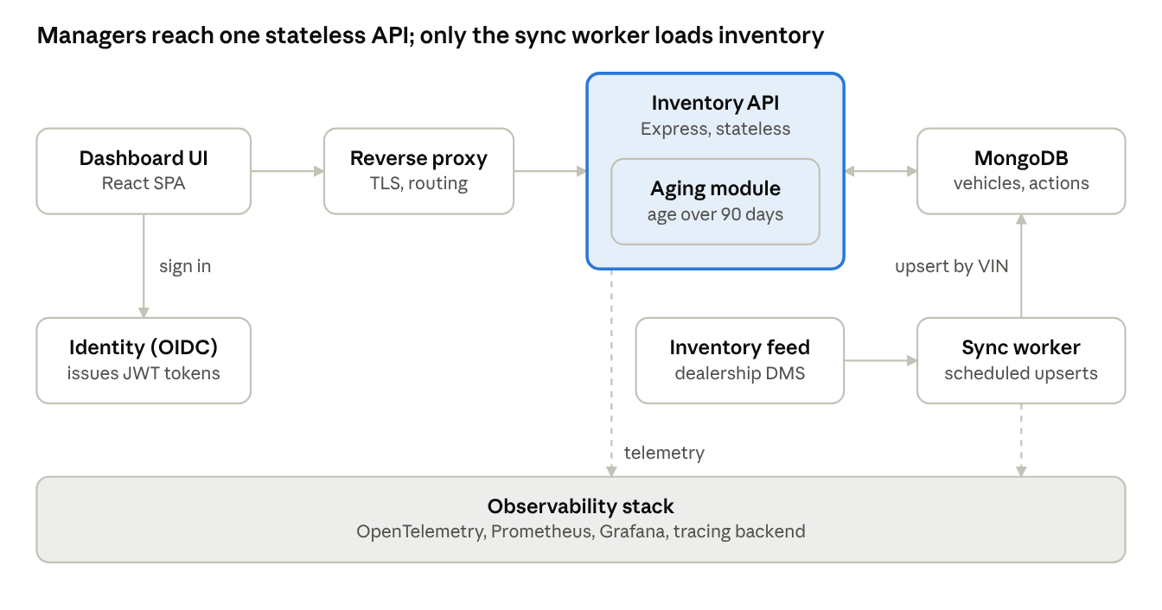
architecture diagram · 8 components
Requests run left to right through the proxy to the API; the sync worker is the only writer of inventory, and dashed lines show telemetry.

4. Component Roles
Each component has one job, so any of them can be scaled, replaced or debugged on its own.
Component | Role
Dashboard UI (React SPA) | Renders KPIs, the aging-stock panel and the filterable table; sends filter and action requests to the API.
Reverse proxy / gateway | Terminates TLS, serves the static UI, rate-limits and routes /api traffic.
Identity provider (OIDC) | Authenticates managers and issues tokens that carry dealership_id and role.
Inventory API (Node.js/Express) | Validates tokens, enforces tenant scope, runs filter queries, computes age_days and is_aging, and writes actions.
Aging module (inside the API) | Single place that owns the aging rule and threshold, so list, panel and KPIs always agree.
Sync worker | Pulls the dealership inventory feed on a schedule and upserts vehicles by VIN; records each run's result.
MongoDB | Stores vehicles and the append-only action log; the only system of record.
Observability stack | Collects logs, metrics and traces from the UI, API and worker (section 11).

5. Data Flow
Ingest path (inventory to database)
- The sync worker requests the latest vehicles from the inventory feed (DMS).
- It upserts each vehicle by VIN and marks vehicles no longer in the feed as sold or removed.
- It records the run (start, end, rows changed, errors) for monitoring.
Read path (manager opens the dashboard)
- The UI loads and the manager signs in through the identity provider.
- The UI calls GET /vehicles/summary, GET /vehicles/aging and GET /vehicles with the current filters and a bearer token.
- The API verifies the token, adds dealership_id to every query, and reads from MongoDB.
- The API computes age_days and is_aging and returns each vehicle with its current action.
Write path (manager logs an action)
- The manager picks a status (for example, Price Reduction Planned) on an aging row.
- The UI sends POST /vehicles/{id}/actions.
- The API checks the vehicle belongs to the dealership and is aging, then inserts a document in vehicle_actions.
- The API returns the new current action; the UI updates the row and refreshes the KPIs.

6. Technology Choices
Layer | Choice | Justification
Frontend | React + TypeScript (Vite), TanStack Query and Table | Mature ecosystem for sortable, filterable tables; typed API contracts; Query handles caching and refetching for near-real-time data.
Backend | Node.js 20 + Express (TypeScript) | One language (TypeScript) across UI and API with shared types; non-blocking I/O suits many concurrent read-heavy requests; request validation with Zod.
Database | MongoDB | Document model fits vehicle records; compound indexes serve the filter and aging queries; each logged action is an insert-only document; a managed option (Atlas) removes database operations.
Data access | Mongoose + migrate-mongo | Typed models with schema validation, and versioned index and data migrations.
Sync | Scheduled worker container (node-cron) | Simple and sufficient for 5-15 minute syncs; no message broker needed at this scale.
Auth | OIDC with JWT access tokens | Standard, delegates identity to an existing provider, and carries tenant and role claims.
Packaging and deploy | Docker containers on a managed container platform | Reproducible builds; the API is stateless so it scales horizontally.
Observability | OpenTelemetry, Prometheus, Grafana, JSON logs | Vendor-neutral instrumentation with widely supported dashboards and alerting.
Testing | Jest, Supertest, Playwright | Unit and API tests for the aging rule; end-to-end test of the filter and log-action flow.

7. Data Model
vehicles collection (one document per vehicle)
Field | Type | Notes
_id | ObjectId | Primary key
dealership_id | ObjectId | Indexed; tenant scope
vin | string | Unique index
make, model, year | string / int | Indexed for filtering
price | Decimal128
status | string | in_stock, sold or on_hold
date_received | date | Source of truth for age
vehicle_actions collection (append-only log, one document per logged action)
Field | Type | Notes
_id | ObjectId | Primary key
vehicle_id | ObjectId | References vehicles._id; indexed
action_status | string | e.g. Price Reduction Planned, Transfer to Another Lot, Wholesale/Auction, Promotion Planned, No Action Needed
notes | string | Optional
created_by | ObjectId | User who logged it
created_at | date | Used to find the latest action
The latest document per vehicle (by created_at) is its current action; earlier documents give an audit trail. Indexes: vehicles has a unique { vin: 1 } and a compound { dealership_id: 1, status: 1, date_received: 1 }; vehicle_actions has { vehicle_id: 1, created_at: -1 }. Actions are kept in their own collection, not embedded in the vehicle, so the history can grow without enlarging vehicle documents.

8. Core Logic: Aging Stock
Age is derived, never stored, so it is always current:
age_days = today - date_received
A vehicle is aging when age_days > 90 and status = in_stock. The threshold lives in configuration (default 90) so it can change per dealership without a deploy. Aging queries use an index on (dealership_id, status, date_received).

9. API Design
Endpoint | Purpose
GET /vehicles?make=&model=&min_age=&max_age=&aging=true&sort=&page= | Filtered, paginated inventory list. Each item includes age_days, is_aging, and current_action.
GET /vehicles/aging | Aging stock sorted by age descending, plus summary counts.
GET /vehicles/summary | KPIs: total units, aging units, aging %, average age.
POST /vehicles/{id}/actions | Log a status or action (body: action_status, notes).
GET /vehicles/{id}/actions | Action history for one vehicle.
Validation: the vehicle must belong to the caller's dealership, and an action can only be logged on an aging vehicle in v1.

10. Frontend Design
- Header KPIs: total units, aging units (highlighted in red/amber), average age.
- Aging Stock panel: pinned at the top, listing oldest vehicles first with age badges and current action.
- Inventory table: sortable columns, filter bar (make, model, age range, aging only), server-side pagination.
- Action control: inline dropdown plus notes field on each aging row; saves via POST with optimistic update and error rollback.
- Aging rows use color-coded badges (for example, 90-120 amber, 120+ red) and are never conveyed by color alone (include text labels for accessibility).

11. Observability Strategy
The goal is to answer three questions quickly: is the dashboard up, is the data fresh, and where is a slow or failing request spending its time. All services use OpenTelemetry so logs, metrics and traces share the same trace ID.
Signal | What we capture | Tooling
Logs | Structured JSON with timestamp, level, trace_id, request_id, dealership_id, user_id and route. No VINs in free text and no personal data. Sync runs log start, end, rows upserted and errors. | JSON to stdout, collected by the platform log service
Metrics | Request rate, error rate and latency per route (RED). Database query time and pool use. Sync last-success timestamp, duration and rows changed. Business gauges: total units, aging units, actions logged. | Prometheus, Grafana dashboards
Traces | One trace per request across UI, API and database; separate spans for the filter query and the aging calculation. Each sync run is its own trace. | OpenTelemetry SDK, exported to a tracing backend (for example Tempo or Jaeger)
Frontend | Page load time, failed API calls and uncaught errors, tagged with the same trace ID. | OpenTelemetry web SDK
Alerts (starting targets, tune after launch)
- API 5xx rate above 1% for 5 minutes.
- p95 latency of GET /vehicles above 500 ms for 10 minutes.
- No successful inventory sync in 30 minutes (data freshness).
- Database connection pool saturated.
Health checks: /healthz (process is up) and /readyz (database reachable), used by the platform for restarts and routing.

12. Non-Functional Considerations
- Freshness: inventory sync every 5-15 minutes; UI polls or refetches on focus.
- Performance: a dealership holds hundreds to low thousands of vehicles, so indexed MongoDB queries with pagination are sufficient; no cache needed initially.
- Security: tenant isolation enforced in every query; role-based access (manager can log actions, others read-only).
- Reliability: idempotent sync (upsert by VIN); action writes are single-document inserts, so they are atomic.
- Observability: request logging, sync-job success/failure alerts.

13. Key Trade-offs
- Computed age vs. stored age: computed avoids stale data at the cost of a small query expression; indexing date_received keeps it fast.
- Append-only action log vs. single status field: the log adds a little complexity but provides history and accountability for managers.
- Polling vs. WebSockets: polling is simpler and adequate for "near real-time"; WebSockets can be added if sub-minute updates are required.

14. Future Enhancements
- Automated alerts when a vehicle crosses 60/90 days.
- Suggested actions based on market price and days-to-sell benchmarks.
- Group-level dashboards across multiple dealerships.
- Export to CSV and integration with pricing tools.

15. How GenAI Assisted This Design
Claude (Anthropic's AI assistant) was used as a design partner to draft and structure this document. It sped up the first draft; the decisions below still need the author's review.
Design phase | How GenAI helped | What a human must verify
Requirements | Turned the three requirements into goals, non-goals and edge cases (for example, what counts as aging, sold vehicles). | That the 90-day rule and non-goals match the dealership's real policy.
Architecture | Proposed a three-tier layout with a separate sync worker and compared polling with WebSockets. | That the sync approach fits the real inventory feed (DMS access, rate limits).
Data model and API | Drafted the vehicles and vehicle_actions collections, indexes and REST endpoints. | Field types, indexes and query plans against real data volumes.
Technology choices | Suggested a stack and a justification for each layer; the author then switched the backend to Node.js and the database to MongoDB. | That the stack fits the team's skills and existing infrastructure.
Observability | Listed logs, metrics, traces and starting alert thresholds. | Alert thresholds, once real traffic exists.
Review | Identified trade-offs (computed vs stored age, action log vs single status field). | Final trade-off decisions.
Prompting approach: the original assignment text was given as context, then refined in steps: first a brief design, then the specific deliverables (diagram, component roles, data flow, technology list, observability, this section).
Limits and safeguards
- AI output can be plausible but wrong, so every number (thresholds, intervals) is labelled a starting target, not a measured fact.
- No real dealership or customer data was shared with the assistant.
- The design should be checked against the real inventory feed and security requirements before implementation.

